**ANTRIAN UNTUK RUMAH SAKIT ISLAM**

**Dosen pengampu : Mirza Sutrisno, S.SI., M.KOM**



Disusun Oleh (Kelompok 8):

1. Irfan Pandu Aji (22040700002)

2. M. Taqi Wijdan (22040700036)

3. Assyifa Nur Maulidia (22040700018)

4. M. Maulana Soddiq (22040700024)

5. M. Thoriq Ramadhan (22040700087)

6. M. Rizky Aulia

**PROGRAM STUDI INFORMATIKA**

**FAKULTAS TEKNIK**

**UNIVERSITAS MUHAMMADIYAH JAKARTA**

**2022**

**START**

**YES**

**NOO**

**PENDAFTARAN BERHASIL DILAKUKAN**

**PILIH JENIS DOKTER**

**PILIH JENIS KAMAR**

**DAFTAR**

**MASUKAN MENU DAFTAR**

**INGIN MENGULANGINYA LAGI**

**END**

**MENDAPATKAN TOTAL BIAYA, KAMAR, DAN DOKTER**

Nama : Irfan Pandu Aji

NIM : 22040700002

Link Github :

Flow APPS

#include <iostream>

#include <string>

using namespace std;

int main()

{

string penyakit;

string nama;

string alamat;

string NIM;

int dokter;

int lama;

int kamar;

string kelamin;

int harga;

int jasa;

char lagi;

awal:

cout << "++++++++++++++++++++++++++++++++++++++++++++" << endl;

cout << "========Rumah Sakit Islam Cempaka Putih========" << endl;

cout << "++++++++++++++++++++++++++++++++++++++++++++" << endl;

cout << " Masukkan Data Pasien Mahasiswa/Umum Dibawah " << endl;

cout << endl;

cout << "Masukkan Nama Anda : ";

getline(cin, nama);

cout << endl;

cout << "Masukan NIM Anda : ";

getline(cin, NIM);

cout << endl;

cout << "Masukkan Alamat Anda : ";

getline(cin, alamat);

cout << endl;

cout << "Masukkan Jenis Kelamin : ";

getline(cin, kelamin);

cout << endl;

cout << "Masukkan Lama Menginap (Jumlah Hari) : ";

cin >> lama;

cout << endl;

cout << "Jenis Kamar:" << endl;

cout << "1. Kelas I" << endl;

cout << "2. Kelas II" << endl;

cout << "3. Kelas III" << endl;

cout << "4. Kelas VIP" << endl;

cout << "5. Kelas VVIP" << endl;

cout << "Pilih Jenis Kamar Anda [1-5]:" << endl;

cin >> kamar;

switch (kamar)

{

case 1:

harga = 800000;

cout << "Kelas I" << endl;

cout << "Tarif 800000" << endl;

break;

case 2:

harga = 600000;

cout << "Kelas II" << endl;

cout << "Tarif 600000" << endl;

break;

case 3:

harga = 300000;

cout << "Kelas III" << endl;

cout << "Tarif 300000" << endl;

break;

case 4:

harga = 1300000;

cout << "Kelas VIP" << endl;

cout << "Tarif 1300000" << endl;

break;

case 5:

harga = 1500000;

cout << "Kelas VVIP" << endl;

cout << "Tarif 1500000" << endl;

break;

default:

cout << "Tidak Tersedia" << endl;

}

cout << endl;

cout << "Dokter:" << endl;

cout << "1. Dokter Anak" << endl;

cout << "2. Dokter Penyakit Dalam" << endl;

cout << "3. Dokter THT" << endl;

cout << "4. Dokter Bedah" << endl;

cout << "5. Dokter Umum" << endl;

cout << "Masukkan Pilihan Anda [1-5]:" << endl;

cin >> dokter;

switch (dokter)

{

case 1:

jasa = 70000;

cout << "Dokter Anak" << endl;

cout << "Tarif 70000" << endl;

break;

case 2:

jasa = 80000;

cout << "Dokter Penyakit Dalam" << endl;

cout << "Tarif 80000" << endl;

break;

case 3:

jasa = 60000;

cout << "Dokter THT" << endl;

cout << "Tarif 60000" << endl;

break;

case 4:

jasa = 100000;

cout << "Dokter Bedah" << endl;

cout << "Tarif 100000" << endl;

break;

case 5:

jasa = 50000;

cout << "Dokter Umum" << endl;

cout << "Tarif 50000" << endl;

break;

default:

cout << "Tidak Tersedia" << endl;

}

cout << "++++++++++DATA MAHASISWA++++++++++" << endl;

cout << "Nama Anda :" << nama << endl;

cout << "NIM :" << NIM << endl;

cout << "Alamat Anda :" << alamat << endl;

cout << "Jenis Kelamin :" << kelamin << endl;

cout << "Lama Menginap :" << lama << endl;

cout << "Jenis Kamar :" << kamar << endl;

cout << "Dokter :" << dokter << endl;

cout << "Yang Harus Dibayar :" << jasa + harga << endl;

cout << endl;

cout << "Ingin Mengulangi Lagi (Y/N)?" << endl;

cin >> lagi;

if (lagi == 'y' || lagi == 'Y')

{

goto awal;

}

if (lagi == 'n' || lagi == 'N')

{

goto selesai;

}

selesai:

cout << "Terima Kasih Atas Kunjungan Anda di Rumah Sakit Islam Cempaka Putih" << endl;

return 0;

}

Dokumentasi

1. 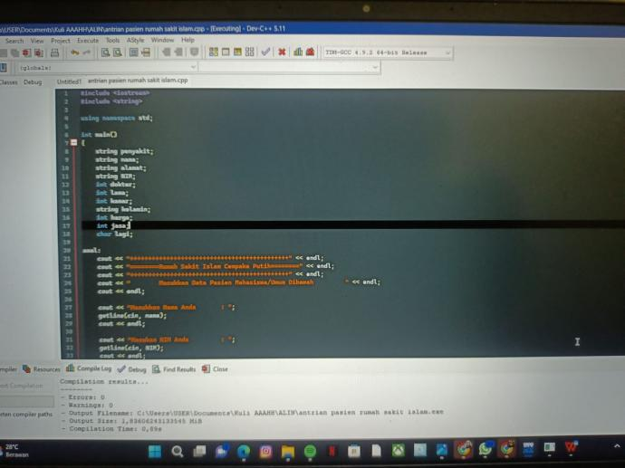
2. 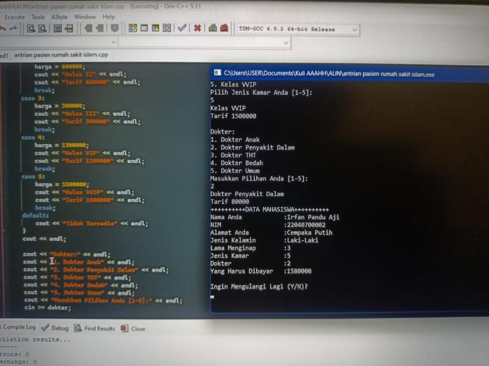
3. 